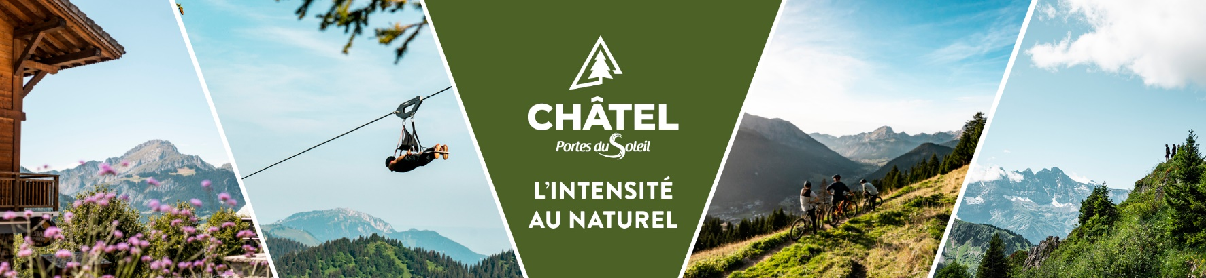

**Weather**

**Thursday 18th of September 2025**

**Sunny.** The sun is radiant from morning to evening. Weak wind Southwest.

*Min temperatures in plains and valleys: 10/12°C*

*Max temperatures in plains and valleys: 26/29°C*

*Iso 0°C: 4600m*

*Water temperature – Lake Geneva: 20°C*

**Friday 19th of September 2025**

**Good weather.** The conditions remain fully sunny throughout the day. Weak wind Southwest.

*Min temperatures in plains and valleys: 12/14°C*

*Max temperatures in plains and valleys: 27/30°C*

*Iso 0°C: 4600m*

*Water temperature – Lake Geneva: 20°C*

**Saturday 20th of September 2025**

**Beautiful day.** A few high clouds pass through our sky, but the sun remains very generous. The heat is remarkable for the period. Moderate wind South.

*Min temperatures in plains and valleys: 13/15°C*

*Max temperatures in plains and valleys: 28/31°C*

*Iso 0°C: 4400m*

*Water temperature – Lake Geneva: 20°C*

**Sunday 21st of September 2025**

**Degradation.** The morning is indeed sunny, but some cloud banks are already circulating. In the afternoon, the sky is charging much more frankly, on the sidelines of a stormy pluvial front. The latter crosses our massifs from West to East in the evening. Moderate wind Southwest.

*Min temperatures in plains and valleys: 12/15°C*

*Max temperatures in plains and valleys: 24/27°C*

*Iso 0°C: 4000m*

*Water temperature – Lake Geneva: 20°C*

**Trends from Monday 22nd to Wednesday 24th of September**

**Showers. Cooler.**