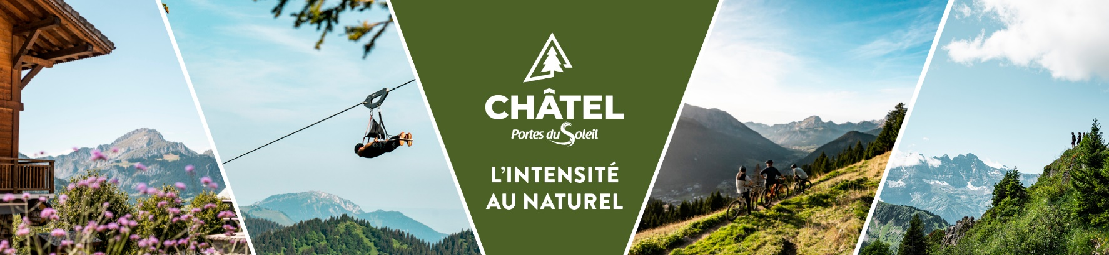

**Weather**

**Tuesday 20th May 2025**

Showers. A few sunny spells on the Haute-Savoie/Northern Savoie side at the start of the day, while the skies are very heavy elsewhere with showers, particularly from the east of Isère to the south of Savoie. The showers become more widespread in the afternoon, mainly affecting the mountain ranges, and continue into the early evening.

Minimum temperatures between +10 and +13 degrees.

Maximum temperatures between +19 and +22 degrees.

Isotherm 0° at around 2800 metres.

Light westerly wind.

**Wednesday 21st May 2025**

Very mixed. Showers are rare in the morning, when the sky is divided between cloud banks at medium altitudes and clear spells. These clouds rise and become heavier again in the afternoon, when showers (less heavy and frequent than the previous day) may return almost everywhere. On the plains there will be few showers and fairly clear spells.

Minimum temperatures between +10 and +13 degrees.

Maximum temperatures between +20 and +24 degrees.

Isotherm 0° at around 2800 metres.

Light wind from the west-north-west.

**Thursday 22nd May 2025**

Autumn. A gloomy, damp and cool day. Frequent and widespread precipitation in the morning, affecting little of the Oisans/Haute-Maurienne. In the afternoon, the precipitation will tend to be progressively confined to the mountain ranges and clear skies will gradually return at the end of the day to the plains to the west of the region.

Minimum temperatures between +10 and +14 degrees.

Maximum temperatures between +16 and +19 degrees.

Isotherm 0° at around 2100 metres.

Moderate north-westerly wind.

**Friday 23rd May 2025**

Fine weather returns to the lowlands. In the mountains, conditions will be more hesitant, with scattered cloud banks and fine spells of sunshine (2-3 drops possible in the afternoon).

Minimum temperatures between +7 and +11 degrees and maximums reaching +18 to +22 degrees.

**Saturday 24 and Sunday 25 May 2025**

Saturday looks set to be sunny, with just a few high clouds. On Sunday the clouds will become more numerous again, making for mixed conditions, but the weather should remain dry.

**Reliability:** Fairly good until Friday, then very average.