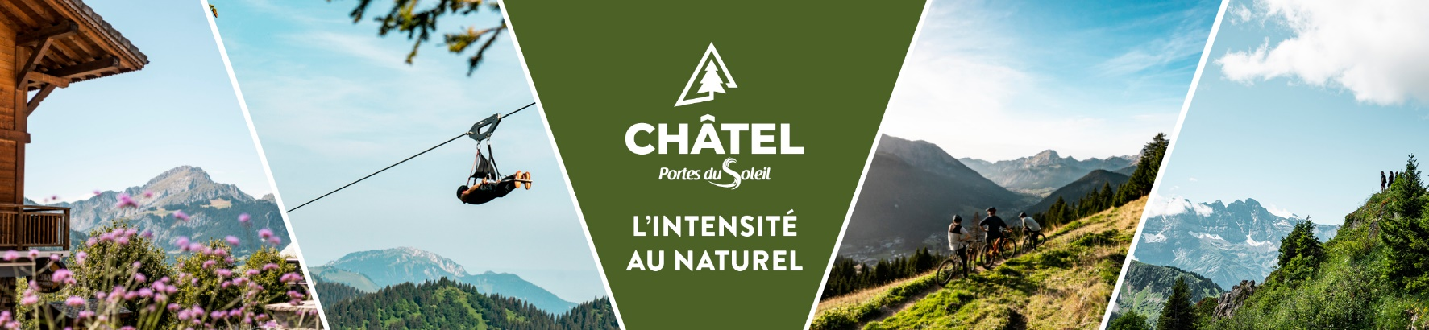

**Weather**

**Tuesday 29th of April**

**Partly cloudy**. **Beautiful morning, very sunny everywhere, quickly mild**. Cumulus clouds move in over the higher ground before midday. They will bring **areas of shade to the mountains in the afternoon** and may be accompanied by **brief isolated showers** (mainly towards Haute-Savoie and the south of Isère). There will be fewer, more organised showers than the previous day.

Minimum temperatures between +6 and +10 degrees.

Maximum temperatures between +21 and +24 degrees.

Isotherm 0° at around 3000 metres. Light wind, predominantly thermal breezes.

**Wednesday 30th of April**

**Summer feeling**. **Continuing fine weather**. **Beautiful morning, bright sunshine**. Cumulus clouds over the mountain ranges from midday and into the afternoon, particularly towards the Pre-Alps and Haute-Savoie. The risk of a brief isolated shower seems to be confined to this department.

Minimum temperatures between +7 and +11 degrees.

Maximum temperatures between +23 and +26 degrees.

Isotherm 0° at around 3100 metres. Light wind, mainly thermal breezes.

**Thursday 1st of May**

**Summer feeling. Fine weather, very sunny and warm in the afternoon.** Even cumulus rare in the afternoon.

Minimum temperatures between +7 and +11 degrees.

Maximum temperatures between +25 and +28 degrees.

Isotherm 0° at around 3400 metres. Light south-south-westerly wind.

**Friday 2nd of May**

**Continuation of summery, very sunny conditions. Quite warm for the time of year, with only occasional fine high cloud.**

Minimum temperatures between +9 and +12 degrees and maximums reaching +26 to +29 degrees.

**Saturday 3rd and Sunday 4th of May**

**Summer weather, very hot and largely sunny despite some high cloud on Saturday**. On **Sunday**, **instability** seems to be making a **comeback**, **with threatening cloudy spells** during the course of the day which could lead to **thundery showers here and there**.

**And for the rest:** Mixed.

**Reliability:** Fairly good.