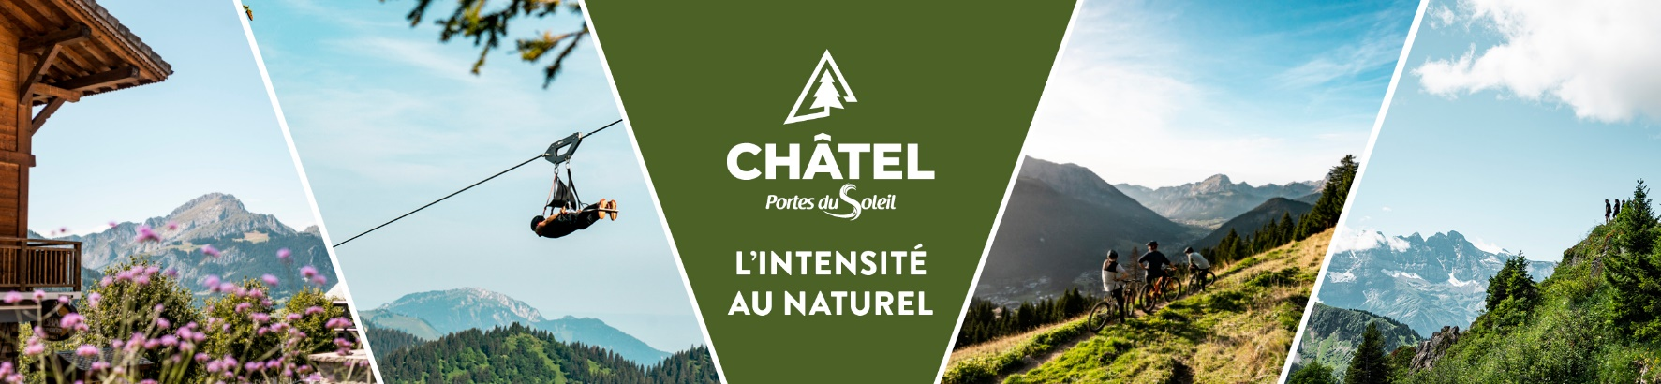

**Weather**

**Monday 30th of June 2025**

**Becoming stormy**. Cloudy spells may affect the sunshine over the south-east of Savoie at the start of the day. Elsewhere, the **morning will be very sunny, before the first cumulus clouds form over the higher ground around midday**. These cumulus clouds then increased in volume as the hours passed. The **skies eventually became threatening in the afternoon**. This instability reaches the inner Alps at the end of the day, then the Jura and the Pre-Alps in the first part of the evening. These thunderstorms will be isolated but sometimes severe (risk of hail, intense rainfall and wind gusts of up to 80-100km/h). The risk of thunderstorms disappears the following night.

*Lowland and valley minimum temperatures: 17/19°C. Max temperatures in plains and valleys: 35/38°C. Iso 0°C: 4500m. Water temperature - Lake Geneva: 24°C.*

**Tuesday 1st of July 2025**

**Same type of weather**. The **morning will be fully sunny**, then **cumulus clouds will swell over the higher ground in the afternoon**. **Local but sometimes strong thunderstorms** then develop between the end of the day and mid-evening, particularly towards the inner Alps. Light south-westerly wind.

*Lowland and valley minimum temperatures: 17/19°C. Max temperatures in plains and valleys: 35/38°C. Iso 0°C: 4300m. Water temperature - Lake Geneva: 24°C.*

**Wednesday 2nd of July 2025**

**Still as hot as ever**. The **sky is perfectly blue in the morning**. In the **afternoon**, **cumulus clouds** budded over the higher ground. As on the previous day, **isolated but sometimes heavy thunderstorms** developed towards the end of the day, especially near the Hautes-Alpes. The following night, this instability ceased. Light south-westerly wind.

*Lowland and valley minimum temperatures: 17/19°C. Max temperatures in plains and valleys: 36/38°C.*

*Iso 0°C: 4200m. Water temperature - Lake Geneva: 24°C.*

**Thursday 3rd of July 2025**

**Radiant sunshine in the morning**, **followed by cloudy spells in the afternoon**, alongside a rainstorm. This crossed our mountain ranges from west to east in the evening. Moderate south-westerly wind.

*Lowland and valley minimum temperatures: 18/20°C. Max temperatures in plains and valleys: 34/36°C.*

*Iso 0°C: 4200m. Water temperature - Lake Geneva: 24°C.*

**Trends from Thursday 3rd to Saturday 5th of July 2025**

**Variable. Significantly cooler.**